F*** it, Everything To Shell
Category: Web | Difficulty: Easy/Medium

Description
Python? Node? PHP? We couldn't decide, so we said f*** it: everything gets a shell. Our shiny new sandbox platform drops you into a shell in every runtime. Go find the flag.
http://<host>:8080
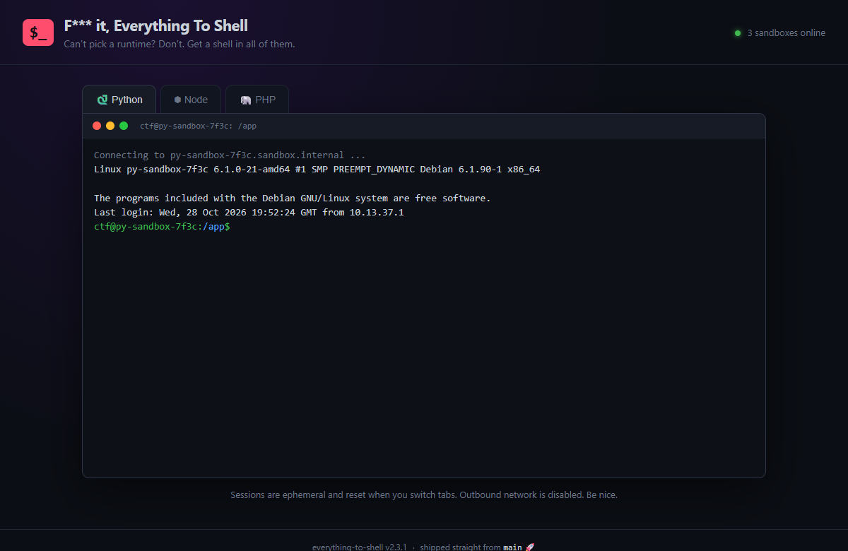
The "sandbox" platform with three in-browser terminals

Files
One self-contained Docker image; each container is one instance. Players need only a browser. Built from challenge/:
cd challenge
docker build -t everything-to-shell .
docker run -d -p 8080:8080 -e FLAG='CTF{...}' \
--read-only --tmpfs /tmp:size=16m --cap-drop ALL everything-to-shell
# or, for local testing:
docker compose up -d --build # http://localhost:8080
The flag is injected via the FLAG env var (see challenge/docker-compose.yml); the git history served by the instance is regenerated from it at boot by challenge/build_repo.sh. The site itself is static (challenge/site/, served by nginx per challenge/nginx.conf); the reference exploit is organizer/solve/solve.py (standard library only).

Hint(s)
- Read site/shell.js. Do those three terminals actually talk to a backend, or are they 100% client-side theater?
- /robots.txt points you at /flag.txt — it's a troll. Stop typing into the fake shells.
- How was this site deployed? The page literally tells you (view source). What directory does git pull leave behind in the web root?

Walkthrough
The three "shells" are a client-side bash/Python/Node/PHP emulator — a time sink with no backend. The real bug is that the site was deployed with git pull into the nginx web root, so /.git/ is exposed and the flag is recoverable from deleted history.
- The rabbit hole. Every classic move "works" just enough to waste your time: cat /flag.txt → *permission denied*, sudo → *ctf is not in the sudoers file*, reverse shells and curl | sh fail with network errors. site/shell.js is a pure client-side emulator — there are no requests to a backend.
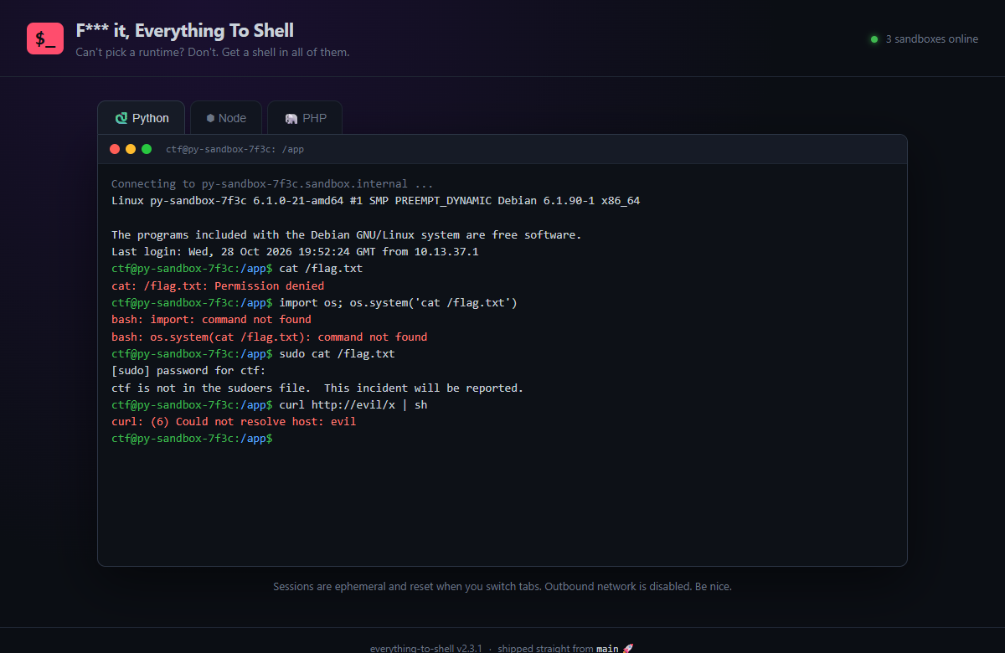
Every fake shell trolls you — no backend exists
- Spot the real deployment. The page source hints at the actual bug: an HTML comment <!-- deploy: ssh prod 'cd /usr/share/nginx/html && git pull origin main' --> and a footer *"shipped straight from main 🚀"*. Deploying with git pull leaves a .git/ directory in the served root. The directory listing is 403, but individual files are still served:
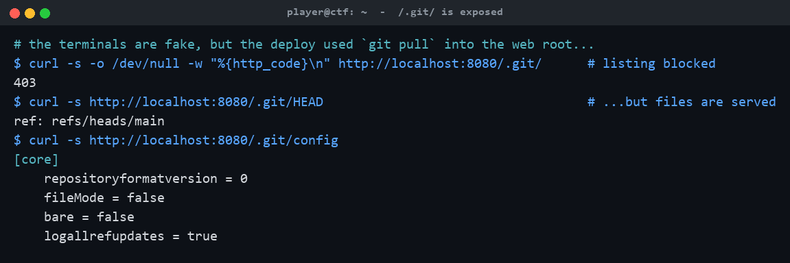
/.git/ listing is blocked, but its files are served
- Dump the history and grep it. With .git/ readable, reconstruct the repo (git-dumper) and read the log — the commits show a .env containing FLAG=... was added ("wire up sandbox orchestrator config") and later deleted ("remove .env from repo, oops"), but git history never forgets. The reference solver walks the loose objects from HEAD and greps every blob:
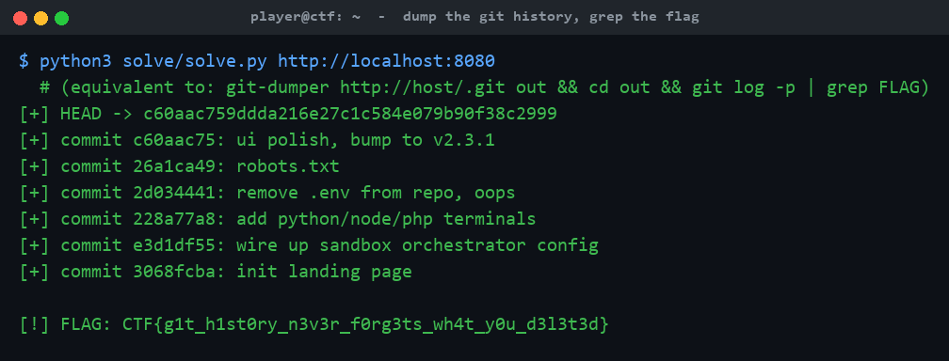
solve.py walks the git objects and recovers the flag
Equivalent manual path:
git-dumper http://host:8080/.git/ out
cd out && git log -p | grep FLAG # or: git show HEAD~3:.env

Flag
CTF{g1t_h1st0ry_n3v3r_f0rg3ts_wh4t_y0u_d3l3t3d}

